**Lab Tasks**

**Task No.01:** Simplify the following equations using Boolean Laws and design the circuits of both given as well as simplified equations on multisim. Construct the Truth Tables to verify that the simplified equations give the same result as that of the original equation.

**a. F = AB + A (B + C) + B (B + C)**

**Un-Simplified Equation Truth Table:**

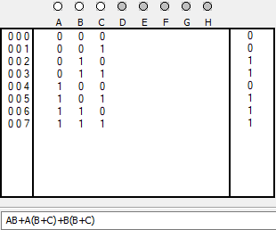

**Un-Simplified Equation Circuit:**

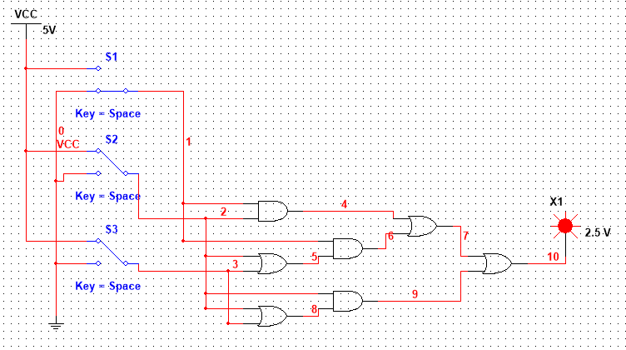

**Simplification:**

F = AB + A(B + C) + B(B+ C)

F = AB + AB + AC + BB + BC

F = AB + AC + B + BC

F = AB + AC + B(1 + C)

F = AB + AC + B(1)

F = AB + AC + B

F = AB + B + AC

F = B(A + 1) + AC

F = B(1) + AC

F = AC + B

**Simplified Equation Truth Table:**

**Simplified Equation Circuit :**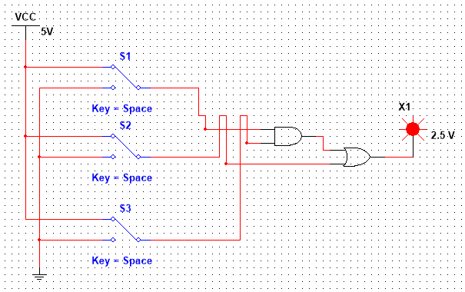

**b. F = (A + C) (AD + AD′) + AC + C**

**Un-Simplified Equation Truth Table:**

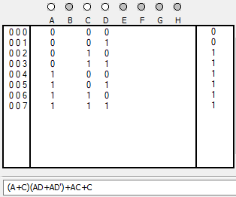

**Un-Simplified Equation Circuit:**

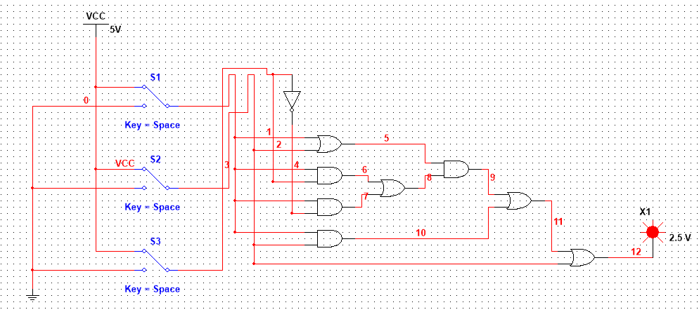

**Simplification:**

F = (A + C) (AD + AD’) + AC + C

F = (A + C) (AD + AD’) + C(A + 1)

F = (A + C) {A(D+ D’)} + C(1)

F = (A + C) {A(1)} + C

F = (A + C) (A) + C

F = AA + AC + C

F = A + C(A +1)

F = A + C(1)

F = A + C

**Simplified Equation Truth Table:**

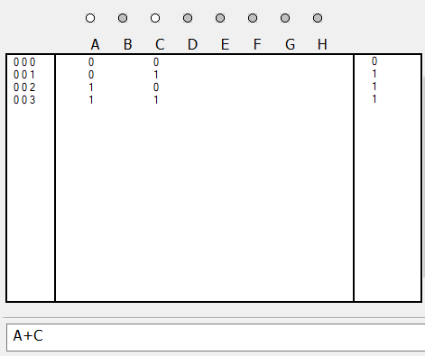

**Simplified Equation Circuit:**

**c. F = A′ (A + B) + (B + A) (A + B′)**

**Un-Simplified Equation Table:**

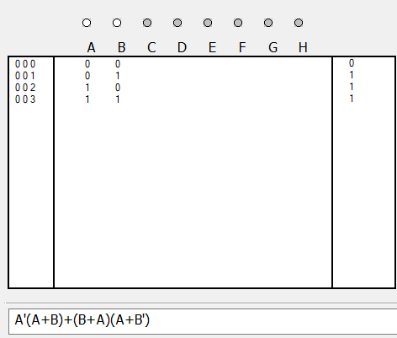

**Un-Simplified Equation Circuit:**

**Simplification:**

F = A′ (A + B) + (B + A) (A + B′)

F = AA’ + A’B + AB + BB’ + AA + AB’

F = 0 + A’B + AB + 0 + A + AB’

F = B(A’ + A) + A(1 + B’)

F = B(1) + A(1)

F = A + B

**Simplified Equation Table:**

**Simplified Equation Circuit:**

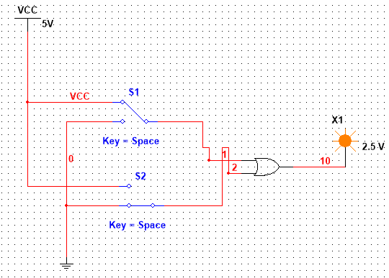

**d. F = A ⋅ (B + C) + A′ ⋅ (B + C)**

**Un-Simplified Equation Table:**

**Un-Simplified Equation Circuit:**

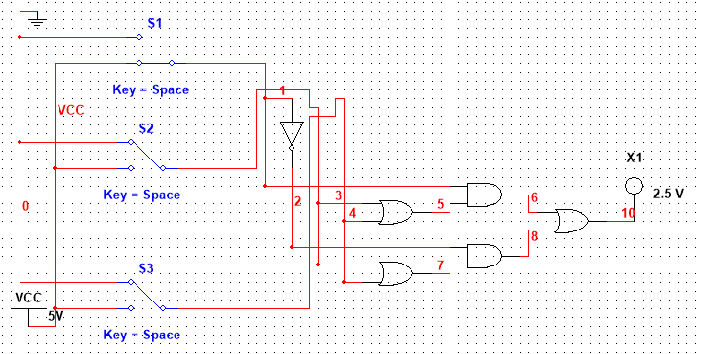

**Simplification:**

F = A ⋅ (B + C) + A′ ⋅ (B + C)

F = AB+ AC +A’B + A’C

F = AB + A’B + AC + A’C

F = B(A + A’) + C(A + A’)

F = B(1) + C(1)

F = B + C

**Simplified Equation Table:**

**Simplified Equation Circuit:**

**e. F = A′ B′ C′ D + A′ B′ CD + A′ BCD + ABCD + AB′ CD**

**Un-Simplified Equation Table:**

**Un-Simplified Equation Circuit:**

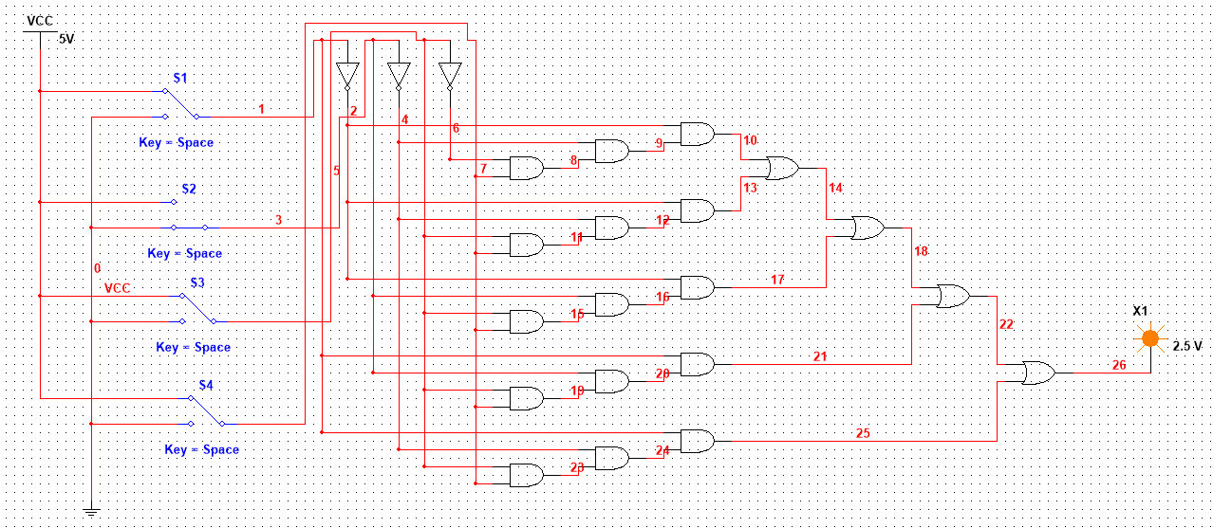

**Simplification:**

F = A′B′C′D + A′B′CD + A′BCD + ABCD + AB′CD

F = A’B’C’D + A’CD(B’ + B) + ACD(B + B’)

F = A’B’C’D + A’CD(1) + ACD(1)

F = A’B’C’D + CD(A’ + A)

F = A’B’C’D + CD(1)

F = A’B’C’D + CD

**Simplified Equation Table:**

**Simplified Equation Circuit:**

**<<END>>**